**About Hutchinson**

HUTCHINSON is a **French vehicle equipment manufacturer with a global reach,** and a leader in rubber processing.

In 2016, Hutchinson generated **a turnover of 4.04 billion** euros. With 95 production sites in 25 countries including in Romania (Brasov), Hutchinson's industrial history stretches back 161 years and its success has been built around innovation in four major divisions: belt transmission, antivibration systems, fluid transfer and sealing.

Hutchinson is a pioneering manufacturer at the forefront of new vehicle technologies, including the Poly V® grooved belt, Stretchy Poly V® elastic belt, hydraulic tensioners.

**Belt transmission**

In belt drive system, **HUTCHINSON is the partner of all main car manufacturers**.

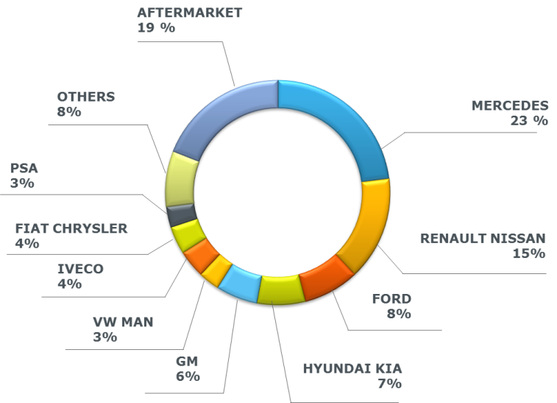

OE HUTCHINSON customers in 2016

Every day 250 000 belts are produced by Hutchinson all over the world.

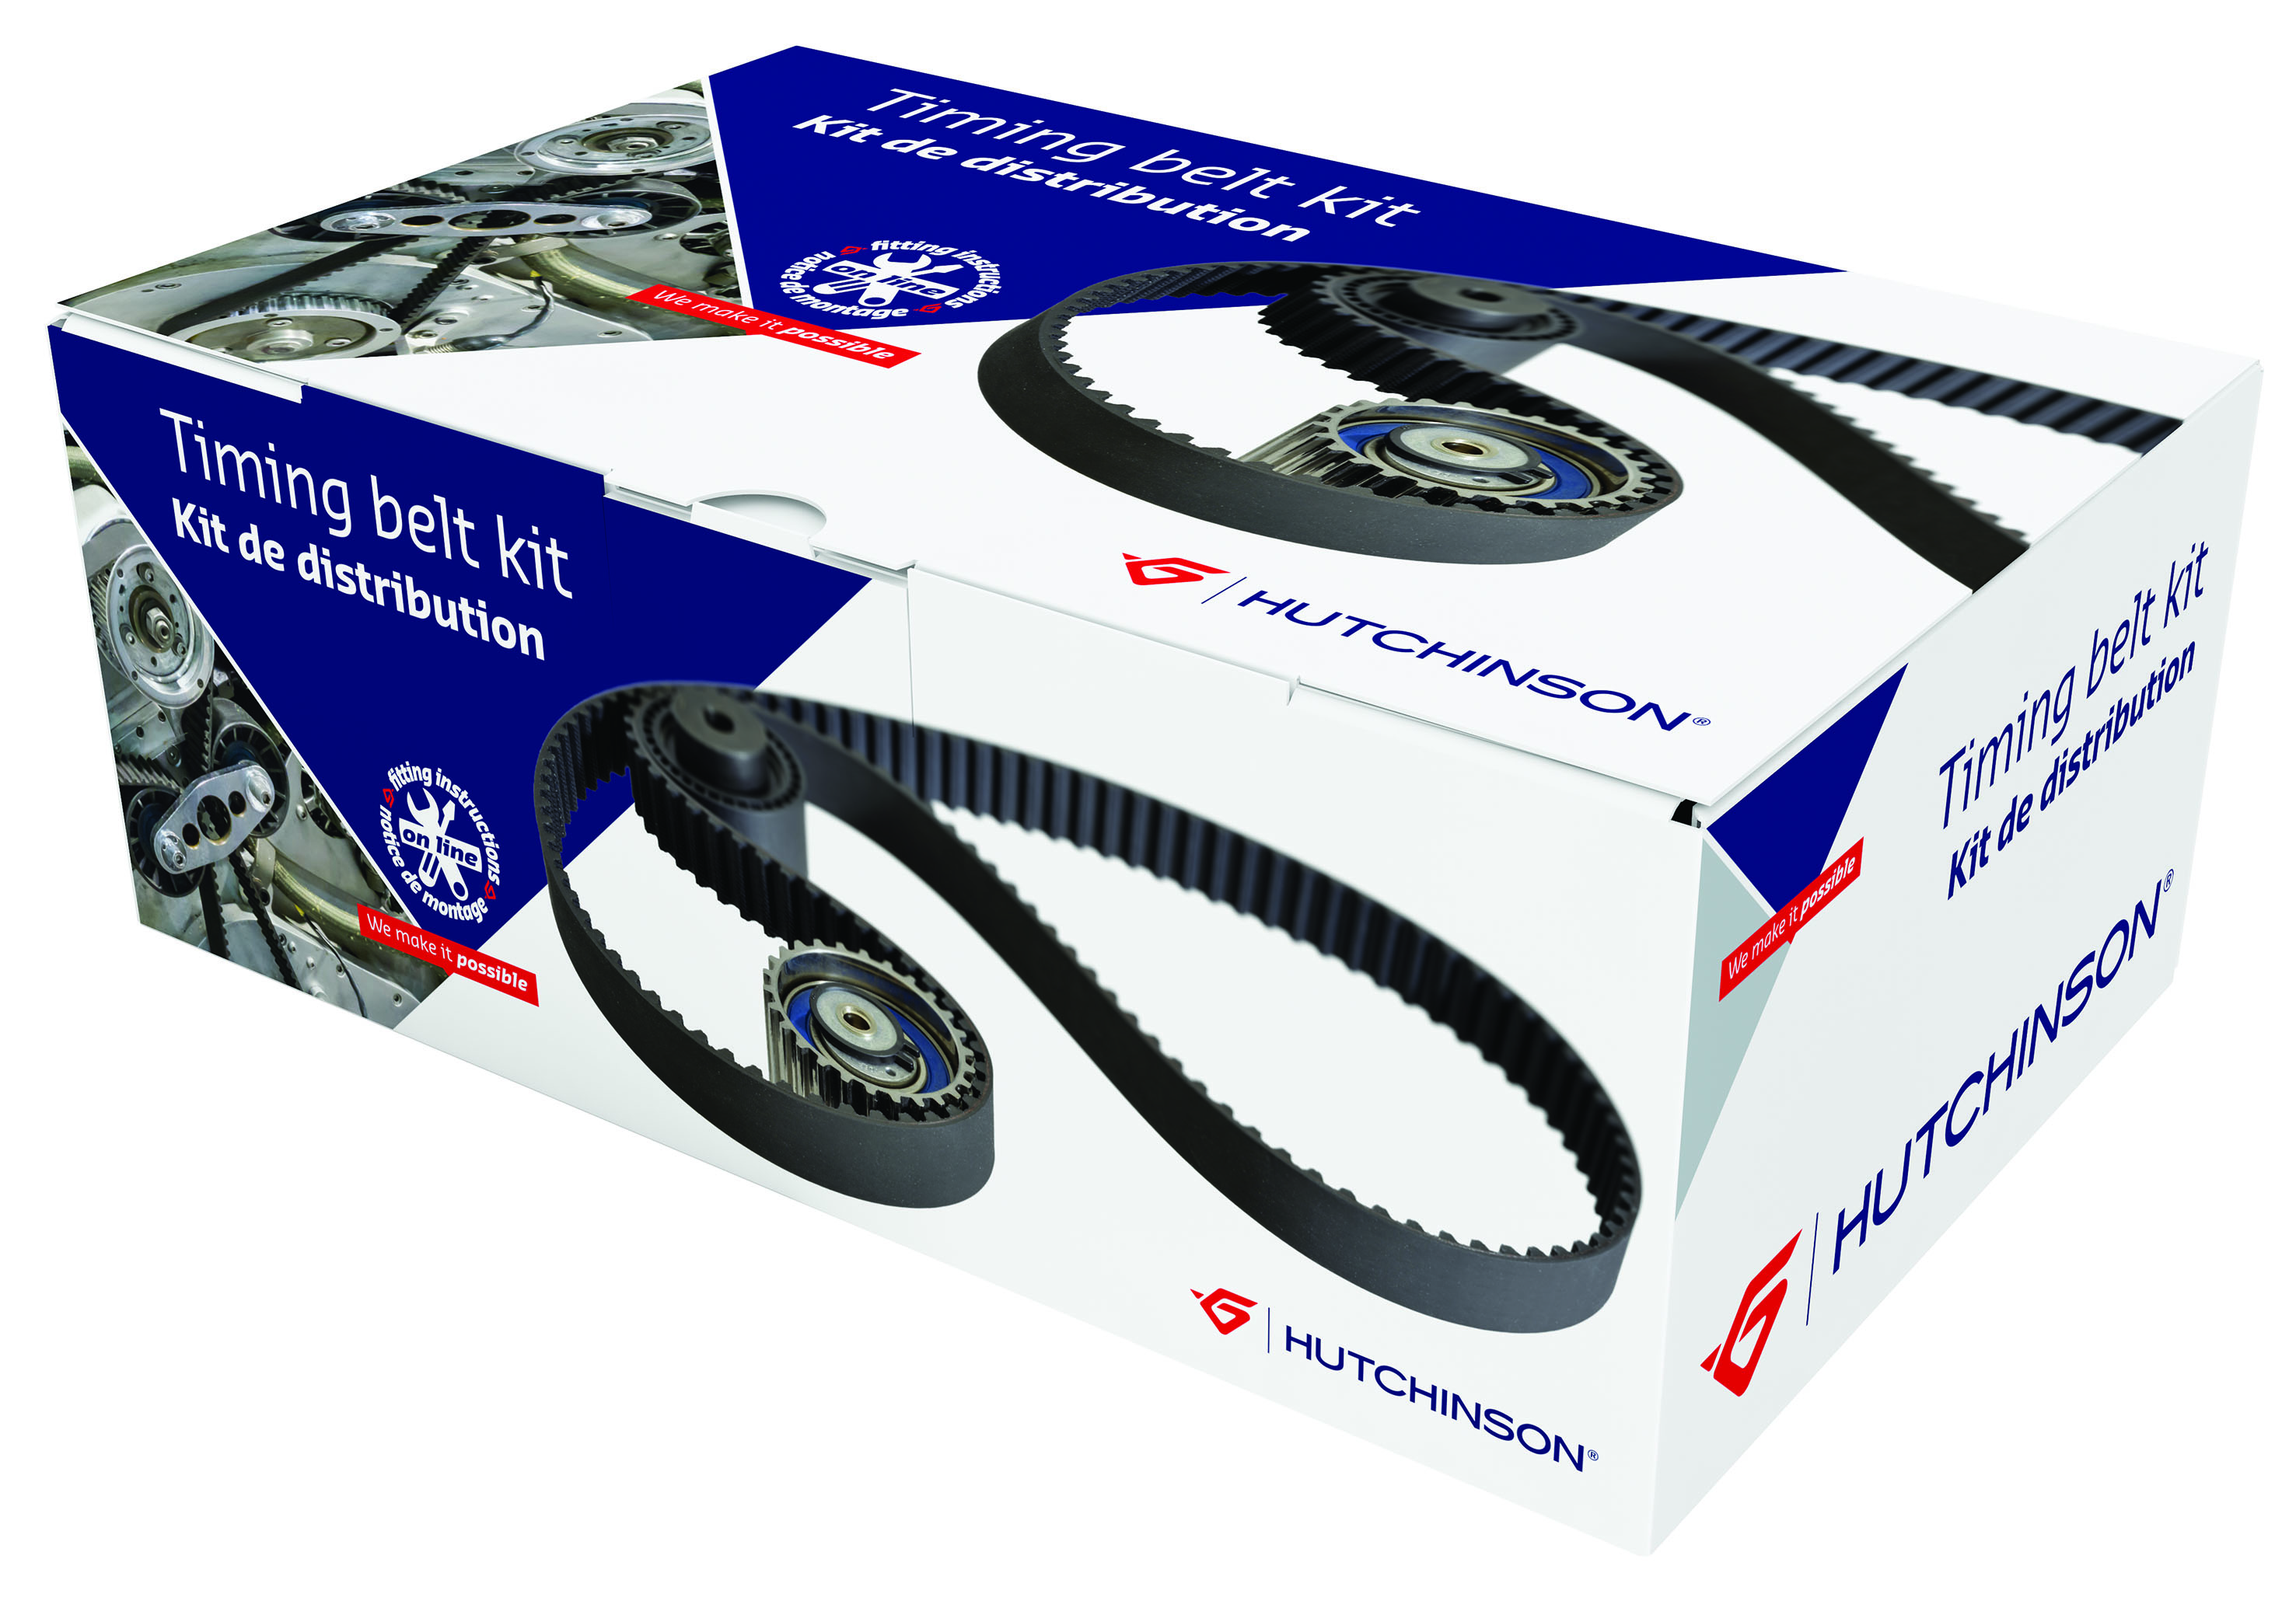In aftermarket the range is composed of **more than 3 300 part numbers**, including timing kits, timing kits with water pump, Poly V belts, tensioners, crankshaft pulley…

**The Timing kit range:**

Composed of 484 part numbers for a European car park coverage of around 97%

An additional range of 186 kits with water pumps is proposed to the market.

Key advantages of the range:

* **A standardized packaging range** (2 sizes) (kits and waterpump kits) with special packing protecting each components
* **OE tensioner** and/or specific Hutchinson development
* 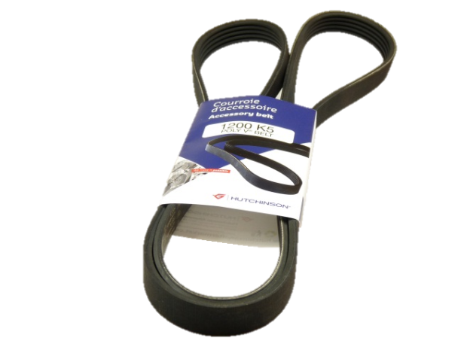**Exclusive online fitting instruction** with unique number on the box

**The Poly V range**:

Hutchinson was the first producer to introduce the Poly V in 1980 on the Mercedes 190 and the first one to launch the Stretchy Poly in 2000 on the Ford Focus.

Today the range is composed of more than 652 references available on stock and 46 stretchy belts.

Key advantages of the range:

* Hutchinson is of **the European leader** of Poly V ® belt
* Exclusive **molding OEM manufacturing process**
* **98% coverage** of European car park
* An additional range of OE tensioners
* A specific assembly tool for the Poly V® belt Stretchy

**Other ranges:**

Additional ranges covering the two loops: timing and accessory belts are proposed such as crankshaft pulleys, overrunning alternators pulleys, timing belts, tensioners and idler

**Short reminder of the technical recommendation to have in mind for belts**

Everyone knows the importance of the timing and accessory belt in the activity of a workshop. On a regular basis accessory belt has to be changed (in average every 120 000Km or 5 years) and for timing it’s the case between 90 000 to 180 000Km. In term of sales it’s the 5th product line after tire, oil, braking and filtration so for sure garages are used to change the belts.

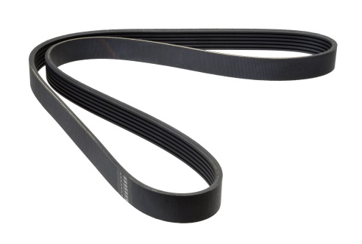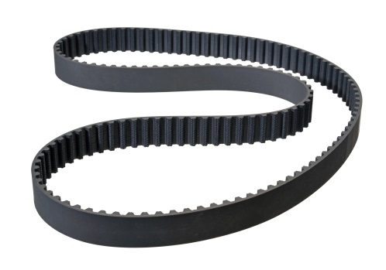

Some specific recommendation can be written again. Indeed risk of a wrong fitting can have big consequences.

* For timing, engine can be destroyed, pistons hitting the valves.
* For accessory, the electric assistance of the direction cannot work anymore (loss of control of the vehicle), and in some case, the accessory belt can fall into the timing belt with the consequences seen above.

**First recommendation concerns the handling of the product.**

* **Never pinch the belt** (that broke the fibers and would cause a brake out)
* Never fit a tensioner or idler that fall on the flour (damage the bearing that decrease his durability)

**During fitting of the timing belt**

* For non-automatic tensioners , **respect the torque** to fit the tensioner
* Always **use new screws** to fit your tensioner or idler.
* When **fitted check the alignment**
* Use an **electronic tensiometer** to respect the recommended tension.

**Exclusive: Hutchinson provides online fitting instruction** with unique number on the box on all timing kits.

**For accessory belt recommendation are almost the same**

* Check the alignment and the tension
* Never use a screwdriver to fit the belt

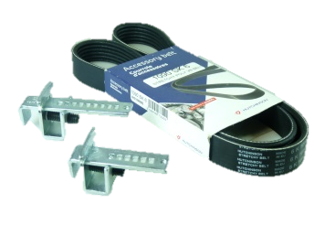**New Technology: the stretchy belt**

Since the year 2000, a new kind of technology has been introduced to the market the **Stretchy belt**. This new product does not need any tensioner; tension is given by the belt which is slightly elastic. This stretchy belt needs a specific tool to be fitted on the car. Hutchinson is proposing a reusable tool the stretchy tool (P/N: XK020)